**Name: Hamza Iqtadar**

**Class: BESE 4-A**

**LAB 1**

**a. Create a file name file1 using terminal; write some text in this file. Create another file name file2, copy the text from file1 to file2, using terminal.**

>file1.txt

>file2.txt

cp file1.txt file2.txt

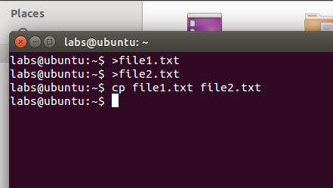

**b. Open the firefox, terminate the firefox process using terminal.**

killall firefox

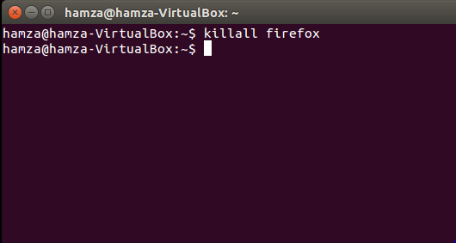

**c. Create directory dir1, place a file named file1. Create another directory dir2, place file name file2 in it. Move file2 to dir1.**

mkdir dir1

mkdir dir2

mv dir2/file2.txt dir1

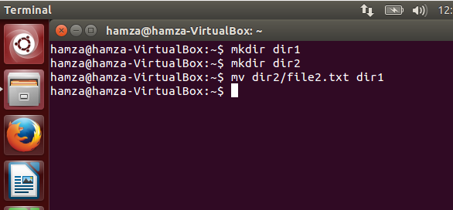

**d. Compress the dir1 and dir2 in a zip file using terminal, named zipped_directories.**

zip zipped_directories.zip dir1 dir2

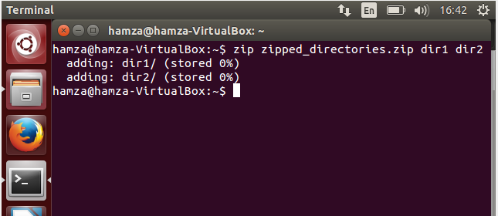

**e. Unzip the compressed file “zipped_directories” in /home/Labs/Documents**

unzip zipped_directories.zip –d /home/Hamza/Documents

